Table of Contents
INTRODUCTION 5
ONE THING LEADS TO ANOTHER AND ANOTHER 6
**Why anything floats at all.** 6
SECTION 2: THE CORE PRINCIPLE 6
A World Is Not Built From Features 7
Here are some powerful historical examples of “shifts” 8
What suddenly became possible? 8
What suddenly became possible? 8
What suddenly became possible? 9
What suddenly became possible? 9
What suddenly became possible? 9
From Cause to Consequence 10
Now the consequences begin to multiply in this world: 10
When you do know: 11
The System Comes First 11
Establishing the Foundation 11
What causes an island to rise into the sky, and why it stays there. 12
SECTION 3: THE FLOATING MECHANICS 12
The Core Force 12
Skystone: The Repelling Material 13
Shieldstone: The Balancing Material 13
The Ratio That Defines Everything 13
Why Size Matters 14
Controlled Height 14
Stability and Constraint 14
Why This Matters 15
SECTION 4: CONSEQUENCES OF THE SYSTEM 15
*When the World Starts Acting Back* 15
We begin with our feet on the ground. 16
This is also where building materials come from. 16
A World That Cannot Stay Still 16
When Land Collides 18
Stability Is Never Permanent 19
Movement Creates Uncertainty 19
Consequences Create Story 19
From System to Civilization 20
SECTION 5: WATER, WEATHER, AND SURVIVAL 20
The Loss of Traditional Seasons 21
Vertical Climate Layers 21
Islands That Create Their Own Weather 22
Permanent Shadow Zones 23
Cold-Locked Regions 23
The Fragility of Survival 25
A Driver of Conflict 25
From Survival to Civilization 26
This is the point where the world stops being an environment and becomes a civilization. 26
SECTION 6: TECHNOLOGY AND SKY TRAVEL 26
*When Civilization Learns to Use the Rules* 26
Technology Begins With Observation 27
The First Problem: Control 27
Why Metallurgists Matter 28
The Birth of the Sky-ship 29
Cloth, Panels, and Controlled Lift 30
Small-Scale Travel: Boards, Platforms, and Light Craft 30
Sky-Boards 31
Sky-Raft 32
Anchors, Chains, and Fixed Structures 32
Technology Is Never Neutral 34
Mastery Creates New Vulnerabilities 34
SECTION 7: WEAPONS AND STRUCTURAL DANGER 35
*When the System Is Turned Against Itself* 35
The First Weapon: Turning Lift Into Force 35
Anti-Ship Warfare 36
Skystone Composites 36
Shieldstone Allocation 36
How It Functions Under Threat 37
Failure to Respond 37
**What This Creates** 37
Armor and the Control of Falling 38
Structural Weapons 38
Collapse as a Weapon 39
Chains, Anchors, and Points of Failure 39
The Environment Is Always Armed 39
Risk Defines Behavior 40
Conflict Without Adding Villains 40
From Danger to Power 41
SECTION 8: ECONOMIES AND RESOURCES 41
*Why People Stay, Struggle, and Fight* 41
Value Begins With Scarcity 41
The Ground and the Sky Are Not Equal 42
MINING: 42
Rich and Poor Are Defined by Function 43
Food Defines Stability 43
Water Is More Valuable Than Gold 44
Trade Routes and Movement 44
Economies Create Conflict Naturally 45
From Survival to Power 45
The World Feeds Itself — or Doesn’t 45
A Living System 46
SECTION 9: SOCIETY AND POWER STRUCTURES 46
*Who Controls the Sky, Controls Everything* 46
Power Is Built on Dependency 46
The Divide Between Sky and Ground 46
Control of Resources Defines Authority 47
Knowledge as Power 48
Cities as Points of Control 48
Trade Networks Become Political Systems 49
Conflict Is Inevitable 49
Not All Power Is Visible 49
Society Reflects the World 50
Power Is Never Permanent 50
From Structure to Story 51
SECTION 10: APPLYING THE SYSTEM 51
*Building a World That Holds Together* 51
The Method, Simplified 51
Step 1: Define the Cause 52
Step 2: Determine the Effect 52
Step 3: Follow the Consequences 52
Step 4: Add Limits 53
Step 5: Let the World Build Itself 53
Step 6: Resist the Urge to Add Without Reason 54
Step 7: You Don’t Need to Explain. You Need to Know 54
A Final Thought on Building Worlds 54
Bringing It Back to Story 54
Closing 55
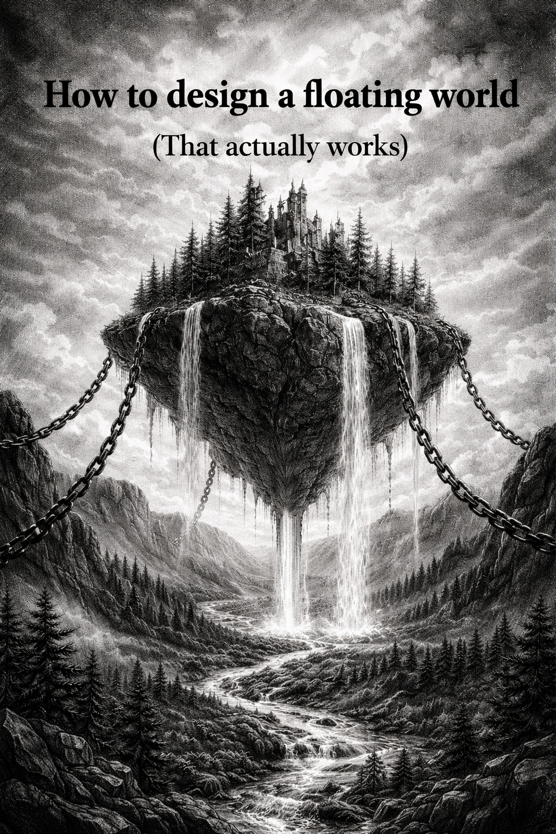

INTRODUCTION

Floating island worlds are everywhere in fantasy.

They look incredible at first glance; land masses drifting in the sky, cities perched above the clouds, ships sailing through open air. It’s a powerful image, and it immediately sparks curiosity. But once you spend any real time in these worlds, something starts to feel off.

The problem is not imagination.

The problem is that most of these worlds don’t make sense.

Islands float because “magic says so.”
Ships fly because they need to.
Gravity behaves however the scene requires.

And once you start asking simple questions, the illusion breaks:

* Why don’t the islands drift away?
* Why don’t they crash into each other constantly?
* Where does water come from?
* How do people survive up there?
* Why hasn’t the entire system collapsed?

Most of the time, there are no answers. Or worse, the answers change depending on what the story needs in that moment.

That inconsistency is what separates a world that feels real from one that feels staged.

A believable world does not need to be realistic in the sense of matching our own physics, but it **does need to be consistent**. If something exists, it must follow rules. If it follows rules, those rules must have consequences. And once consequences exist, they shape everything else; the environment, the people, the economy, and the conflicts that drive the story.

This is where most world-building breaks down.

Writers often begin with the image, the floating island, the sky city, the dramatic view, but stop there. The deeper structure, the system underneath, is either ignored or patched together later. The result is a world that looks good from a distance but falls apart under pressure.

This book takes a different approach.

Instead of starting with the image alone, we start with a system.

We are going to build a world where floating islands exist for a reason, behave according to defined rules, and create natural consequences that ripple outward into every part of the setting. The goal is not to remove imagination, but to support it with structure.

You don’t need to explain every detail to your audience. In many cases, you shouldn’t. But you need to know how it works. Because when you do, everything else becomes easier to build.

This approach can be summarized simply:

ONE THING LEADS TO ANOTHER AND ANOTHER

* Something causes the islands to float
* That cause creates predictable effects
* Those effects produce consequences for the world

From those consequences come:

* geography
* weather patterns
* technology
* trade
* conflict

In other words: story.

What you’re about to build is not just a concept, but a functioning system. One that can support a story, a game, or an entire series without collapsing under its own weight.

We’ll begin with the foundation:

**Why anything floats at all.**

